- Anniversary Flowers

Flower Name | Description | Price (One flower)
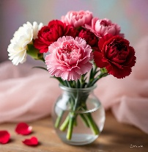  Carnation | Known for their ruffled petals and clove-like scent, carnations symbolize love, fascination, and distinction. | Rs. 100.00
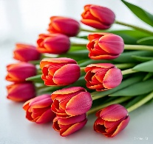  Lily | Elegant and fragrant, lilies represent purity and renewal. They come in many colors, each with its own meaning. | Rs. 150.00
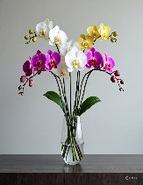  Orchid | Exotic and delicate, orchids symbolize beauty, strength, and luxury. They’re often used in elegant floral arrangements. | Rs. 200.00
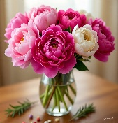  Peonies | Full and lush, peonies stand for romance, prosperity, and good fortune. They bloom beautifully in spring. | Rs. 300.00
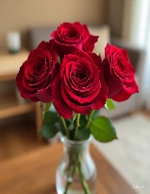  Red Rose | A classic symbol of love and passion, red roses are timeless and often used to express deep emotions. | Rs. 500.00
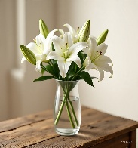  White Lily | These symbolize purity, peace, and remembrance, often used in weddings and funerals for their serene beauty. | Rs. 600.00

- Birthday Flowers

Flower Name | Description | Price
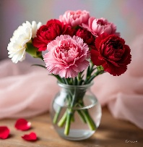  Carnation | Known for their ruffled petals and sweet fragrance, carnations symbolize love and admiration. | Rs. 200.00
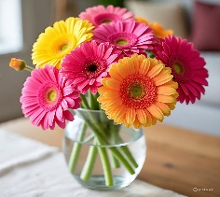  Gerberas | Bright and cheerful flowers that come in many colors, gerberas represent happiness and innocence. | Rs. 350.00
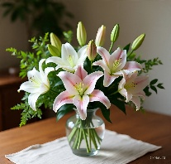  Lily | Elegant and fragrant, lilies represent purity and renewal. They come in many colors, each with its own meaning. | Rs. 700.00
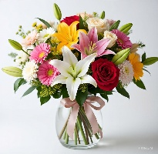  Mix bouquet | A colorful arrangement of different flowers, mix bouquets express joy, celebration, and variety. | Rs. 5000.00
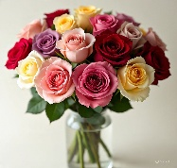  Rose | A classic flower with soft, layered petals, roses symbolize love, beauty, and passion. They come in various colors, each with its own meaning. | Rs. 500.00
  Sun Flower | With large yellow petals and a bold center, sunflowers symbolize warmth, positivity, and loyalty. | Rs. 700.00

- Graduation Flowers

Flower Name | Description | Price
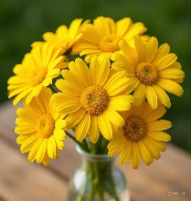  Daisies | Simple and cheerful flowers with white petals and a yellow center, symbolizing purity and innocence. | Rs. 800.00
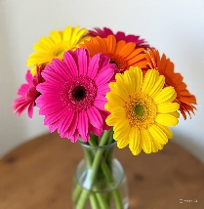  Gerberas | Bright and bold daisy-like flowers, known for their large blooms and variety of colors, symbolizing happiness. | Rs. 900.00
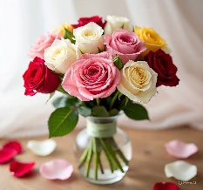  Mix color bouquet | A vibrant arrangement of various colorful flowers, representing joy, celebration, and love. | Rs. 10000.00
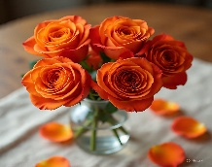  Orange Rose | A striking rose that conveys enthusiasm, passion, and energy | Rs. 600.00
  Sunflower | Large yellow flowers that follow the sun, symbolizing warmth, positivity, and loyalty. | Rs. 700.00
  Yellow Rose | A sunny and cheerful rose that represents friendship, joy, and new beginnings. | Rs. 700.00
- Valentine’s Flowers

Flower Name | Description | Price
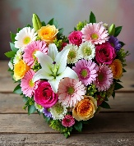  Heart Shape Mix Bouquet | A romantic arrangement of various colorful flowers shaped like a heart, symbolizing love and affection. | Rs. 15000.00
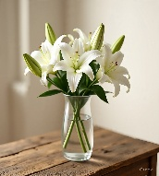  Lily | Elegant, trumpet-shaped flowers that symbolize purity and renewal, available in white, pink, and orange shades. | Rs. 850.00
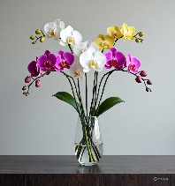  Orchid | Exotic and graceful blooms that represent beauty, luxury, and strength, often used in stylish arrangements. | Rs.400.00
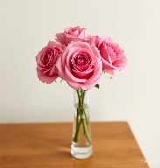  Pink Rose | Soft and delicate flowers that stand for admiration, sweetness, and gentle love. | Rs. 650.00
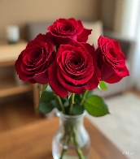  Red Rose | Classic symbol of deep love and passion, often given on romantic occasions. | Rs. 700.00
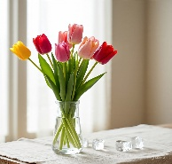  Tulip | Bright, cup-shaped flowers that come in many colors, symbolizing perfect love and springtime joy. | Rs. 700.00
- Wedding Flowers

Flower Name | Description | Price
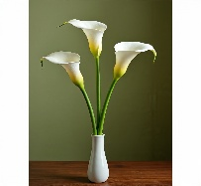  Calla Lily | Elegant, trumpet-shaped flowers known for their smooth curves and classic beauty. | Rs. 900.00
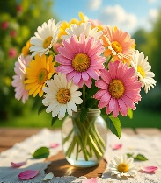  Daisies | Simple and cheerful flowers with white petals and a yellow center, symbolizing innocence. | Rs. 850.00
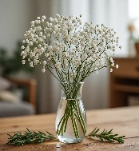  Gypsophila | Also known as baby’s breath, these tiny white blooms are delicate and airy, often used as filler. | Rs.750.00
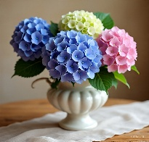  Hydrangeas | Large, round clusters of flowers in soft shades like blue, pink, and white, symbolizing gratitude. | Rs. 800.00
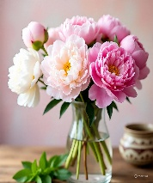  Peonies | Lush, full blooms with a sweet scent, often seen in pink and white, symbolizing romance and prosperity. | Rs. 850.00
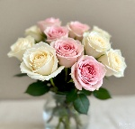  Rose (White or Pink) | Classic and elegant, white roses represent purity and new beginnings. Gentle and lovely, pink roses symbolize admiration, joy, and grace. | Rs.750.00

